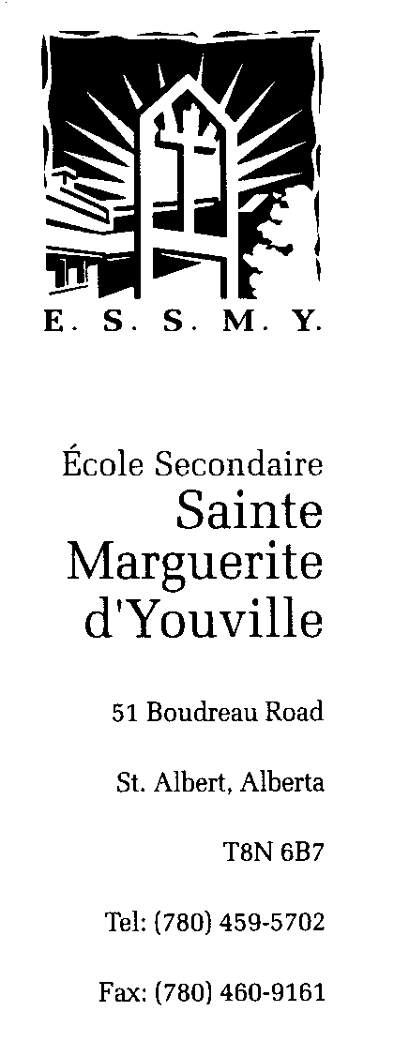

Greater St. Albert Roman Catholic Separate School District No. 734 supports the practice of conducting educational field trips and excursions that enhance student learning as described in the Program of Studies and as aligned with the division mission statement. There are risks associated with every field trip. Please read this parent information carefully so that you can provide a well-informed parental consent for this field trip.

Please note that the board of trustees or the superintendent reserves the right to cancel any field trip up to the departure date in the event that there are severe issues or concerns with student and staff travel.

Educational Assessment:
The educational value of the trip:

General Outcome B
Students will understand, experience and appreciate the health benefits that result from physical activity.

This consent covers both the district and zone cross country meet. The top five finishers from ESSMY in each age category at the district meet will be invited to compete at zones.

Cross Country Districts Meet details: Thursday September 20th 2018
Red Willow Park/Kingswood Park

Districts Itinerary:
8:15 am- Depart from ESSMY and walk to Red Willow Park/Kingswood Park
9:15 am- Jr. High Course Walk Through
10:00 am- Jr. High Races
12:00 pm- Return to ESSMY

Cross Country Zones Meet: Wednesday September 26th
Gold Bar Park, 10955 50 St NW, Edmonton AB

Zones Itinerary:
8:15 am- Depart from ESSMY by bus
9:30 am- Arrive at Goldbar
10:00 am- Course walkthrough
10:30 am -1:00 pm- Categorized runs
1:40 pm- Return to ESSMY by bus

Safety/Risk Assessment:
There is an element of risk in every activity. The safety and well-being of students is our prime concern and attempts are made to manage foreseeable risks inherent in any physical activity. Students need to listen to the instructors in order to do the fitness classes in a safe manner.
- Minor injuries not limited to but including sprained ankles while walking to/from Kingswood park or during a fitness class; should this occur, the teacher in charge will assess the situation, administer First Aid if required, and contact the parents
- Injuries related to transporting students to the various events: vehicular accidents causing injury or death.

I have read and understand the educational and safety (risk) assessments provided concerning the Field Trip to Kingswood Park & Goldbar Park.

I authorize to attend Kingswood Park Race on September 20th 2018 and the Goldbar Park Race on September 26th 2018 (If qualified) by bus.

A copy of this form is posted on the ESSMY website, under athletics, for your consideration.

The following is a list of my child’s medical conditions (including allergies, conditions requiring medication, etc.) a list of medication that my child must take and any special instructions regarding medication storage and administration.

If my child requires medical attention, I authorize the supervisors to seek necessary medical treatment.

Alberta Health Care Number: __________________________________

In case of an emergency I may be contacted at: An alternate emergency contact is:
Home telephone(s): Name:
Work telephone(s): Relationship:
Cellular telephone: Home telephone(s):
Work telephone(s): Cellular telephone:

Signature of Parent/Guardian Date

Print name of Parent/Guardian

