Google Apps for Education

What are Google Apps for Education?
Google Apps for Education is similar to Microsoft Office; they are web-based applications for communicating and creating files such as documents, slideshows and spreadsheets. They provide flexible ways for your children to learn and achieve success. Like all web-based applications, Google Apps for Education can be accessed from any device with an internet connection. This provides students with ongoing access to resources and projects, and allows students to collaborate on projects in real-time.
Your child will have a username and password from school to access their Google Apps for Education account. The account will be in the format of username@g.gsacrd.ab.ca. These accounts are for educational purposes only and are not intended for your child’s personal use.

What are some of the most common Google Apps that my child will use?

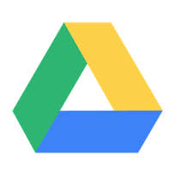
Google Drive is an online file storage system. Students can share files, and edit documents, spreadsheets, and presentations. Students are also able to collaborate in real-time with others who they invite to their documents or files.
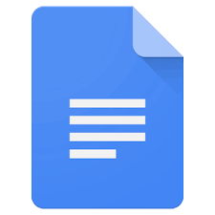
Google Docs is where students can open and create documents. All Docs are stored in Google Drive. Google Docs will open Word documents as well as have the ability to save documents as a Word Document.
Google Slides is a presentation software. Students can create and collaborate on slide shows. Google Slides are stored in Google Drive.
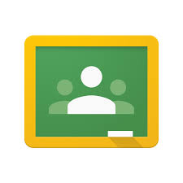
Google Classroom is a way teachers can digitally assign learning activities to students. Students can access class resources and assignments here.

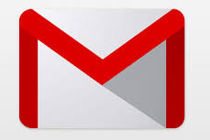
Gmail is your student’s email account. Your child has the ability to send and receive emails related to his/her learning. Teachers, along with parental support, will teach your child that Gmail accounts are for school-use only.

Is my child’s privacy protected when using Google Apps for Education?
Yes, there are extra security and privacy settings. As a Google Apps for Education customer, GSACRD owns our own data. Google does not share or sell our data to third parties. Additionally, there is no advertising in Google Apps for Education services. Please see https://goo.gl/7cZFof for additional information on Google’s Privacy.

