Our Priorities | Our Results | Celebrating Our Faith | A Culture of Service, Safety & Respect | Engaged Learning
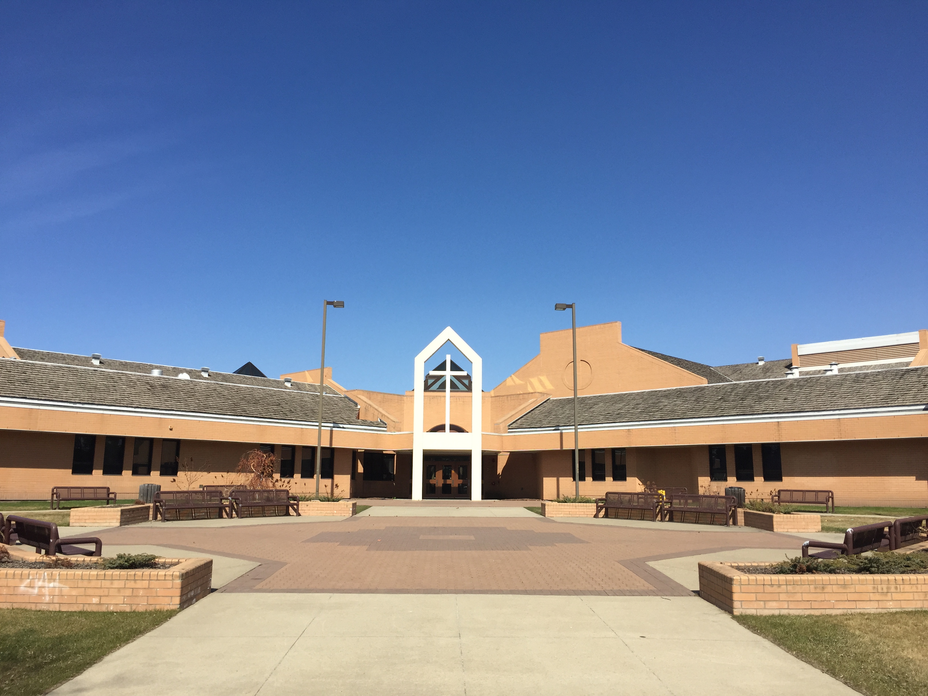 |  | 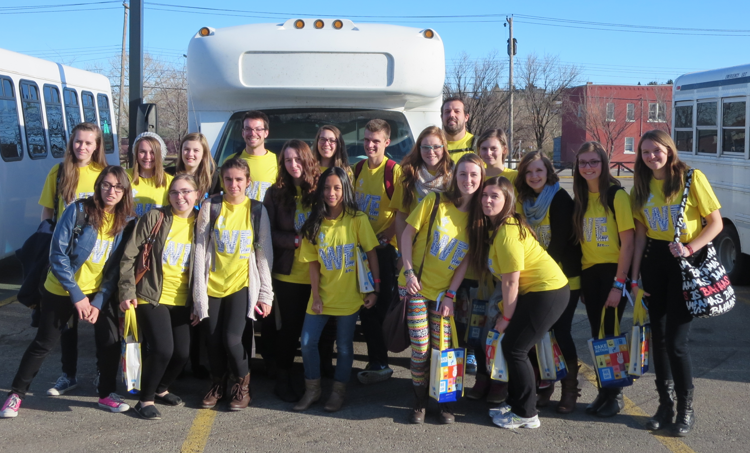 | 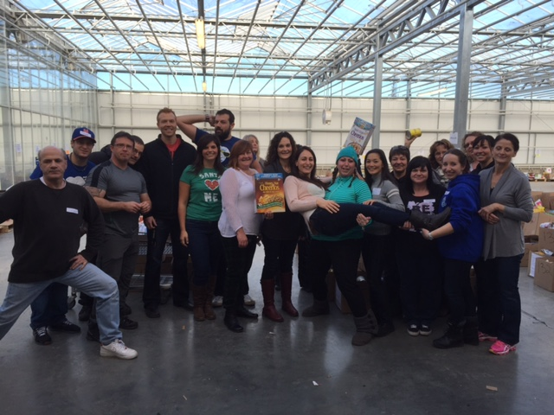 | 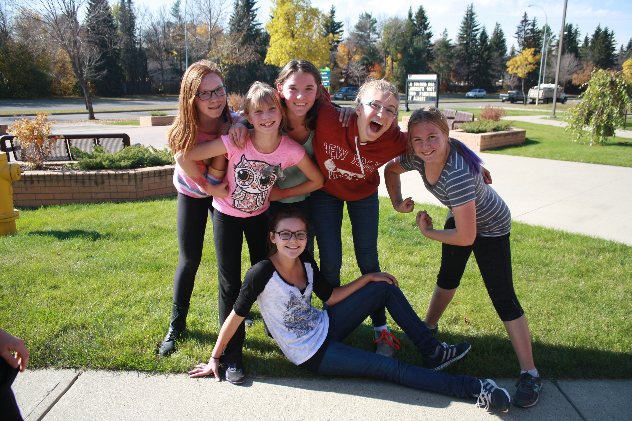
Our two main priorities are:  - Faith – to provide opportunities for everyone in the community to model a life of service  - Learning – to ensure all students experience continued success  On-going strategies are in place to build and strengthen ESSMY’s single-track French Immersion Grades 7 -12 Program. | Our results:  Results on all measures continue to demonstrate that ESSMY is a focussed, vibrant and engaged learning community.  The results below guide us in determining goals for our 2016-2017 school year:  (1) Accountability Pillar Survey – our current results show that 89.8% of our parents, students and teachers are satisfied with the overall quality of basic education at ESSMY. Our goal is to increase this result to 93%.  (2) ESSMY’s Diploma Exams and Provincial Achievement Tests show that ESSMY students continue to do well. Our goal for this year is that 93% of our students attain the acceptable standard and 23% of our students reach the standard of excellence.  (3) Our students feel hopeful for their futures and they are engaged in their learning. The goal as seen on the Student Gallup Poll is that 100% of our students feel hopeful and engaged. | GSACRD’s Faith Goal:  Opening the Doors of Mercy: Love in Action  ESSMY’s Faith Goal:  To further a culture of evangelization, faith formation and vocation within our school, students, staff and parents know, model and witness Jesus Christ.  Strategies to address this goal:  i. teach what it means to live a life with mercy  ii. involve all students in grade level retreats  iii. invite students and families to participate in liturgies, masses, morning prayer and school retreats  iv. share information of Pope Francis’ teachings surrounding mercy  v. participate in fundraisers to support our Development and Peace Project in the Philippines  vi. guide and encourage students in completing their Christian Service Projects  vii. celebrate our first mass in our chapel  Religious Celebrations:  (1) Year Opening Liturgy  (2) Thanksgiving Mass  (3) Special Blessings of Travellers  (4) Advent Mass/Advent Liturgies  (5) New Year’s Liturgy  (6) Ash Wednesday Mass  (7) Lenten Liturgies  (8) Resurrection Mass  (9) Grade 9 Mass  (10) Grad Mass  (11) Reconciliation Opportunities  (12) Individual Classroom Liturgies  (13) Reflections (Advent and Lent)  (14) Remembrance Day Ceremony | Serving the Oppressed and Those in Need:  (1) As a school community, we support the district-wide initiative with Development and Peace through fundraising efforts such as: Pumpkin Carnival with our feeder schools and Annual Skip-a-thon.  (2) Students’ Christian Service Projects help reinforce the call to serve those in need. Projects focussing on providing opportunity for students to feel empathy and to allow students to be of service to familiar needs such as community groups are encouraged.  (3) Our Social Justice Group initiates teachings and projects that are shared with the community whereby others are invited to participate.  Student Safety:  (1) Students complete Digital Citizenship Lessons  (2) Our RCMP Liaison officer speaks to all students about cyber-safety and bullying  (3) Grade 9 students participate in the P.A.R.T.Y Program (Prevent Alcohol and Risk-related Trauma in Youth)  (4) Topics related to safety are addressed at grade level meetings (emergency protocol safety, street safety, on-line safety, etc..) | Strategies in place to increase student engagement and address inclusive learning:  (1) Students complete the Student Gallup Poll survey that measures students’ hope, engagement, well-being, entrepreneurial attitude and career planning. Strategies in place to address these measures are:  (i) Mentorship Club  (ii) Teacher Connections (students are assigned to a teacher)  (iii) Students complete their strengths profile and teachers use the strengths in their teaching.  (iv) Students participate in Career Learning through invited guests, excursions and our career fair.  (v) Flex lessons address topics such as mental health, mindfulness, careers, etc..  (vi) Technology is integrated into the classroom.  (vii) Our universal pyramid of supports is addressed to ensure students’ needs are addressed.  (viii) Cross-curricular and cross-grade lessons.

